**ECEN 454**

**LAB 3**

**NAME:** Jason Gilman

**UIN:** 126006979

**SECTION:** 511

**TA:** Guaynu Gao

**Cell18.spi**



**Inverter**

**Inverter.spi**



**Inverter_simcap.spi**



**Inverter delay**

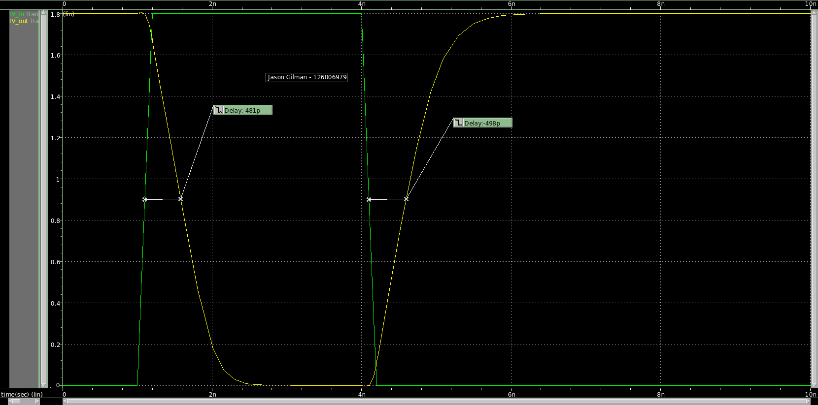

|  |  |  |  |
| --- | --- | --- | --- |
| **Capacitance (fF)** | **Rising Delay (p)** | **Falling Delay (p)** | **Error (%)** |
| 1 | -27.1 | -45.2 | 66.790 |
| 5 | -57.7 | -74.5 | 29.116 |
| 10 | -85.5 | -101 | 18.129 |
| 15 | -109 | -122 | 11.927 |
| 20 | -131 | -144 | 9.924 |
| 25 | -153 | -166 | 8.497 |
| 30 | -175 | -188 | 7.429 |
| 35 | -197 | -210 | 6.599 |
| 40 | -219 | -232 | 5.936 |
| 45 | -240 | -255 | 6.250 |
| 50 | -262 | -277 | 5.725 |
| 60 | -306 | -321 | 4.902 |
| 70 | -351 | -368 | 4.843 |
| 80 | -393 | -410 | 4.326 |
| 90 | -439 | -451 | 2.733 |
| 100 | -481 | -498 | 3.534 |

**Inverter AC**

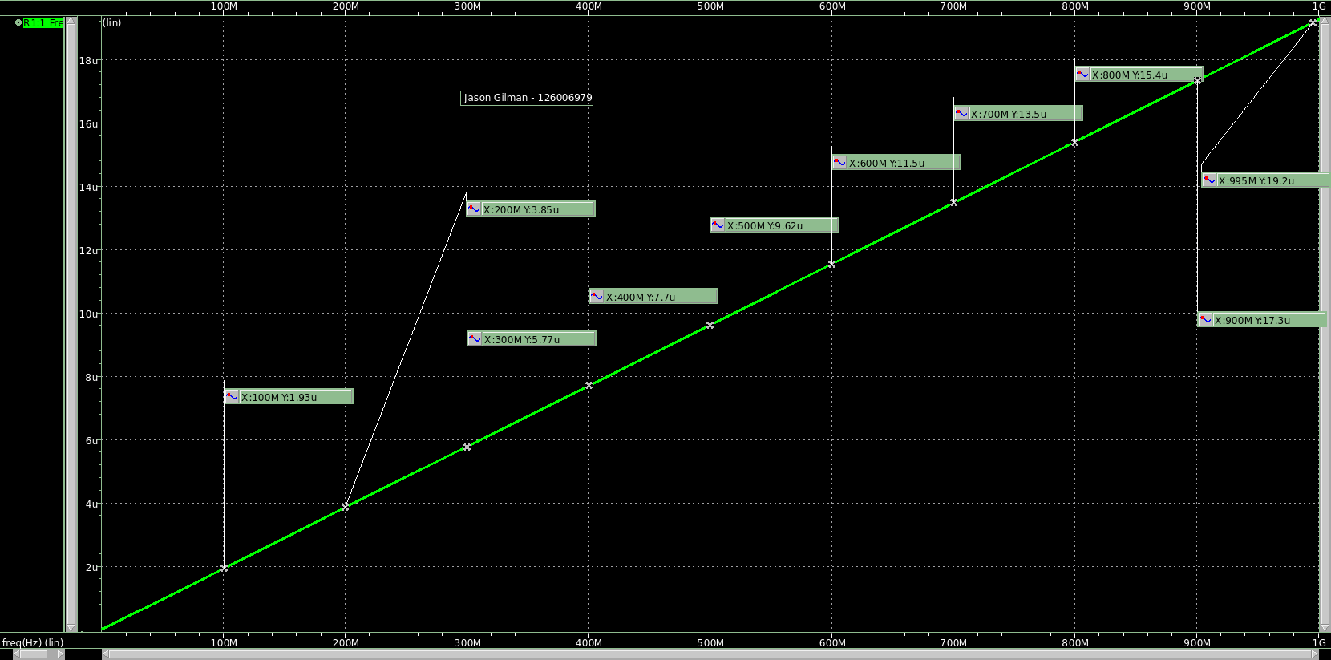

|  |  |  |
| --- | --- | --- |
| **Frequency (MHz)** | **Current (µA)** | **Capacitance (nF)** |
| 100 | 1.930 | 3.072 |
| 200 | 3.850 | 3.064 |
| 300 | 5.770 | 3.061 |
| 400 | 7.700 | 3.064 |
| 500 | 9.620 | 3.062 |
| 600 | 11.500 | 3.050 |
| 700 | 13.500 | 3.069 |
| 800 | 15.400 | 3.064 |
| 900 | 17.300 | 3.059 |
| 995 | 19.200 | 3.071 |
|  |  |  |
|  | **Sink Capacitance** | 3.064 |

**NAND2**

**NAND2.spi**



**NAND2_simcap.spi**



**NAND2 Delay**

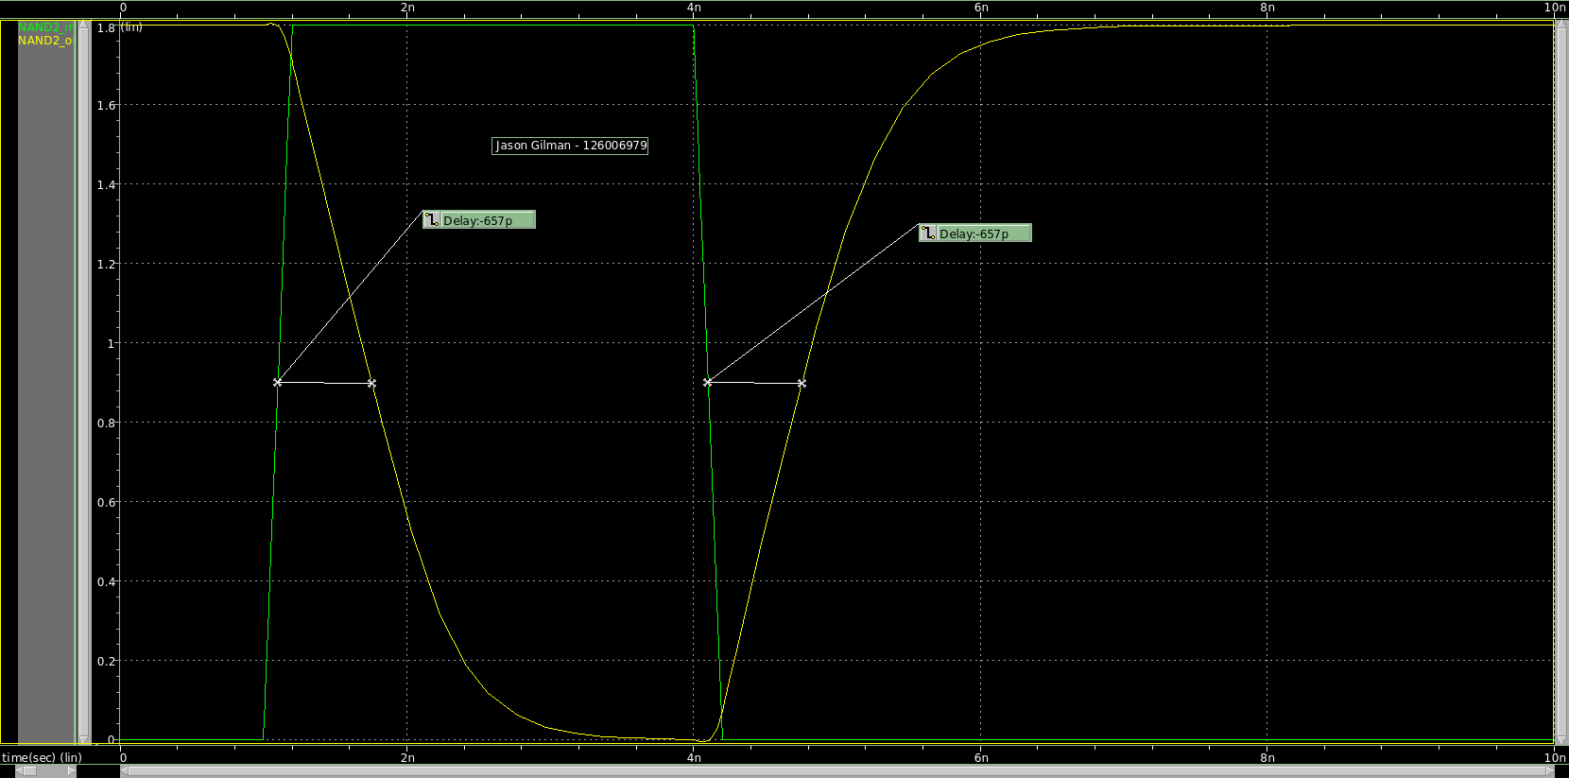

|  |  |  |  |
| --- | --- | --- | --- |
| **Capacitance (fF)** | **Rising Delay (p)** | **Falling Delay (p)** | **Error (%)** |
| 1 | -37.2 | -56.2 | 51.075 |
| 5 | -73.5 | -89.8 | 22.177 |
| 10 | -108 | -121 | 12.037 |
| 15 | -138 | -150 | 8.696 |
| 20 | -169 | -180 | 6.509 |
| 25 | -199 | -210 | 5.528 |
| 30 | -230 | -240 | 4.348 |
| 35 | -262 | -271 | 3.435 |
| 40 | -292 | -299 | 2.397 |
| 45 | -322 | -331 | 2.795 |
| 50 | -351 | -360 | 2.564 |
| 60 | -415 | -418 | 0.723 |
| 70 | -475 | -477 | 0.421 |
| 80 | -535 | -537 | 0.374 |
| 90 | -596 | -596 | 0.000 |
| 100 | -657 | -657 | 0.000 |

**NAND2 AC**

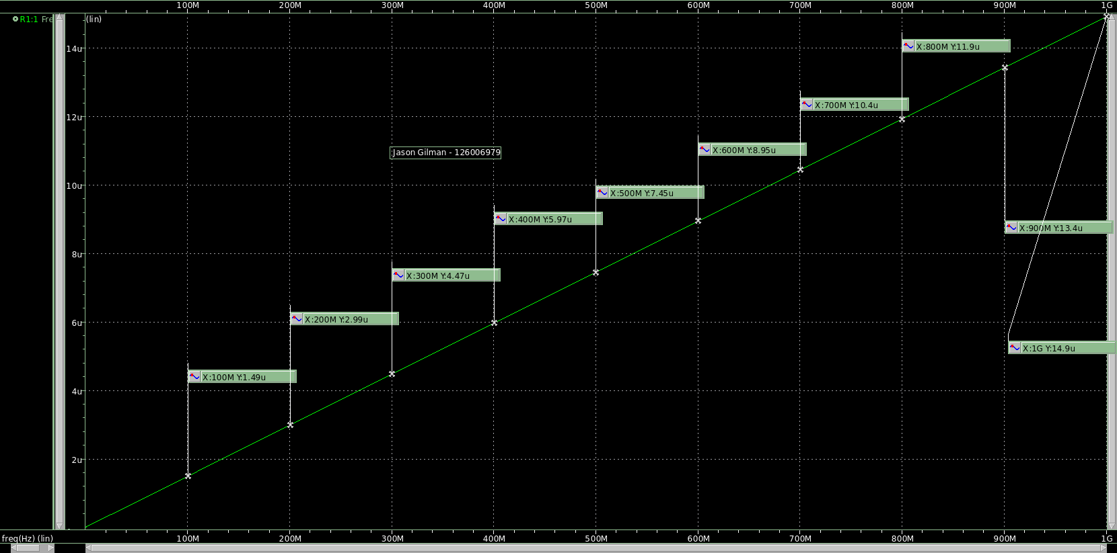

|  |  |  |
| --- | --- | --- |
| **Frequency (MHz)** | **Current (µA)** | **Capacitance (nF)** |
| 100 | 1.490 | 2.371 |
| 200 | 2.990 | 2.379 |
| 300 | 4.470 | 2.371 |
| 400 | 5.970 | 2.375 |
| 500 | 7.450 | 2.371 |
| 600 | 8.950 | 2.374 |
| 700 | 10.400 | 2.365 |
| 800 | 11.900 | 2.367 |
| 900 | 13.400 | 2.370 |
| 995 | 14.900 | 2.383 |
|  |  |  |
|  | **Sink Capacitance** | 2.373 |

**XOR2**

**XOR2.spi**

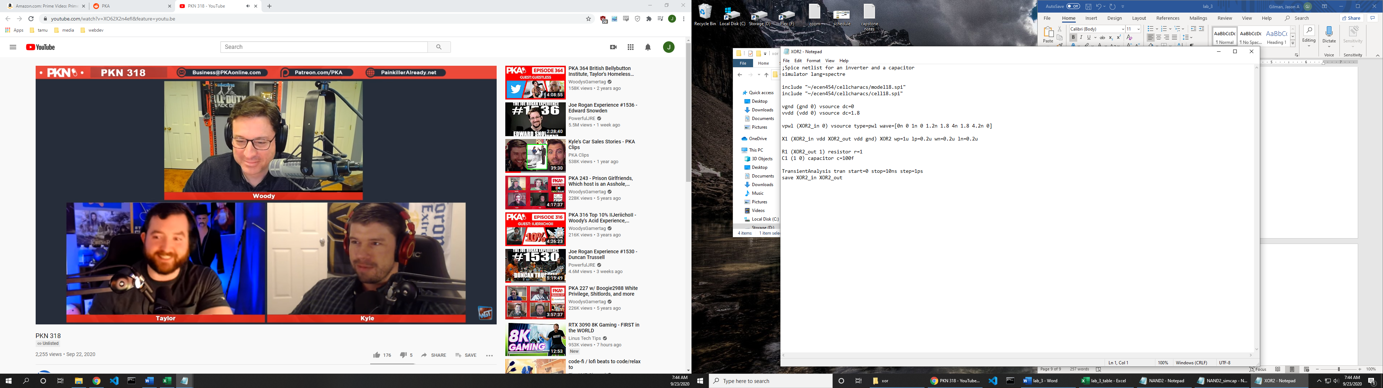

**XOR2_simcap.spi**

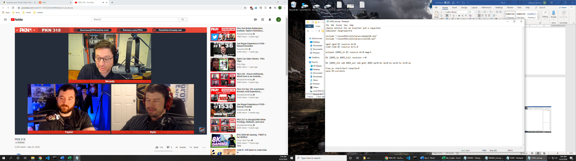

**XOR2 Delay**

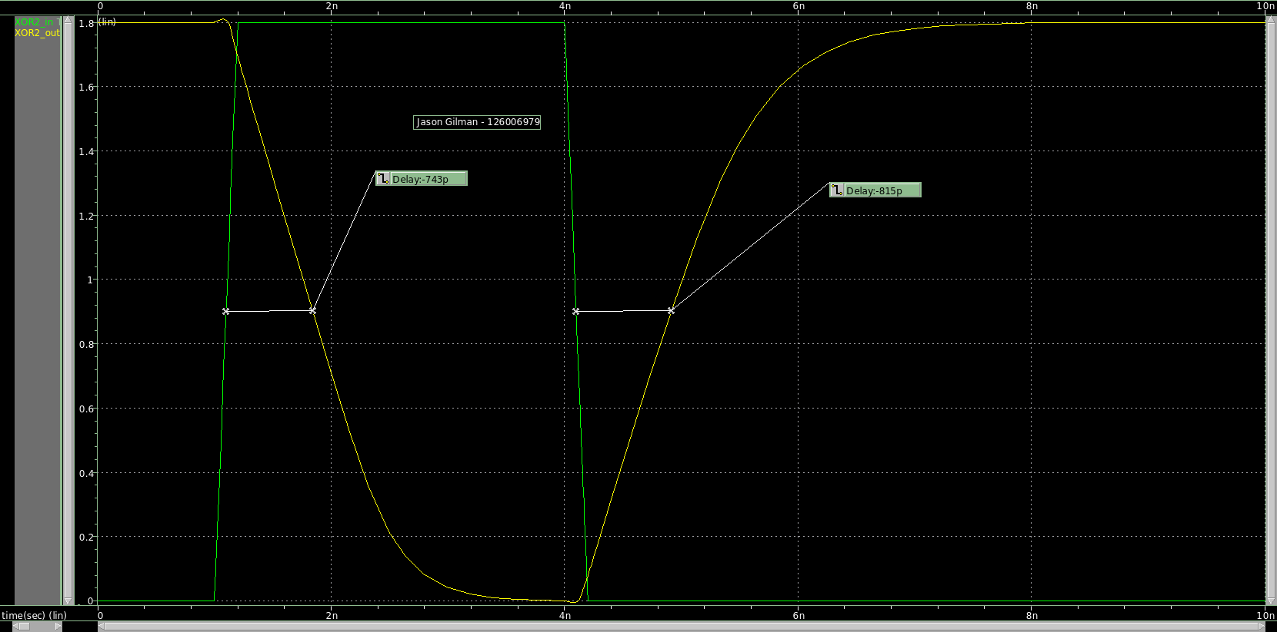

|  |  |  |  |
| --- | --- | --- | --- |
| **Capacitance (fF)** | **Rising Delay (p)** | **Falling Delay (p)** | **Error (%)** |
| 1 | -39.8 | -52.2 | 31.156 |
| 5 | -72.5 | -89.5 | 23.448 |
| 10 | -110 | -129 | 17.273 |
| 15 | -146 | -168 | 15.068 |
| 20 | -181 | -207 | 14.365 |
| 25 | -217 | -244 | 12.442 |
| 30 | -252 | -283 | 12.302 |
| 35 | -288 | -321 | 11.458 |
| 40 | -323 | -359 | 11.146 |
| 45 | -358 | -399 | 11.453 |
| 50 | -393 | -438 | 11.450 |
| 60 | -463 | -511 | 10.367 |
| 70 | -533 | -588 | 10.319 |
| 80 | -604 | -663 | 9.768 |
| 90 | -673 | -741 | 10.104 |
| 100 | -743 | -817 | 9.960 |

**XOR2 AC**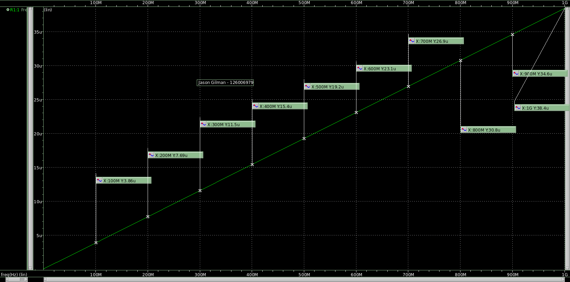

|  |  |  |
| --- | --- | --- |
| **Frequency (MHz)** | **Current (µA)** | **Capacitance (nF)** |
| 100 | 3.860 | 6.143 |
| 200 | 7.690 | 6.120 |
| 300 | 11.500 | 6.101 |
| 400 | 15.400 | 6.127 |
| 500 | 19.200 | 6.112 |
| 600 | 23.100 | 6.127 |
| 700 | 26.900 | 6.116 |
| 800 | 30.800 | 6.127 |
| 900 | 34.600 | 6.119 |
| 995 | 38.400 | 6.142 |
|  |  |  |
|  | **Sink Capacitance** | 6.123 |